EXPERIMENT – 2
PANDAS LIBRARY – BASIC CONCEPT
Aim:
To upload and analyze dataset given in csv format and perform data preprocessing and
visualization
Procedure:
1.Upload the csv file and read it
2. Import the necessities like pandas ,numpy and seaborn
3.Now visualize bar plot for sales over products , line plot for sales over time and correlation matrix
PROGRAM:
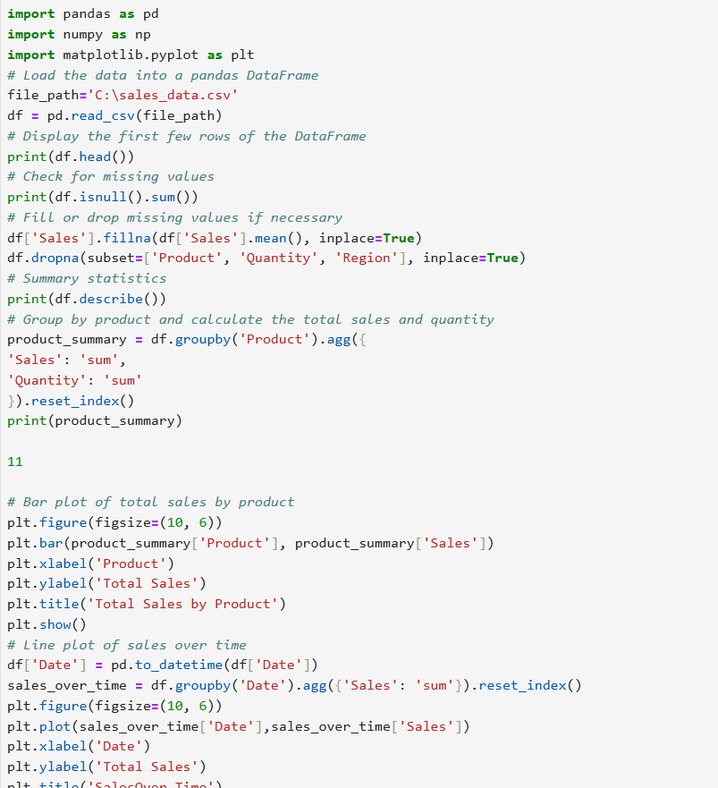
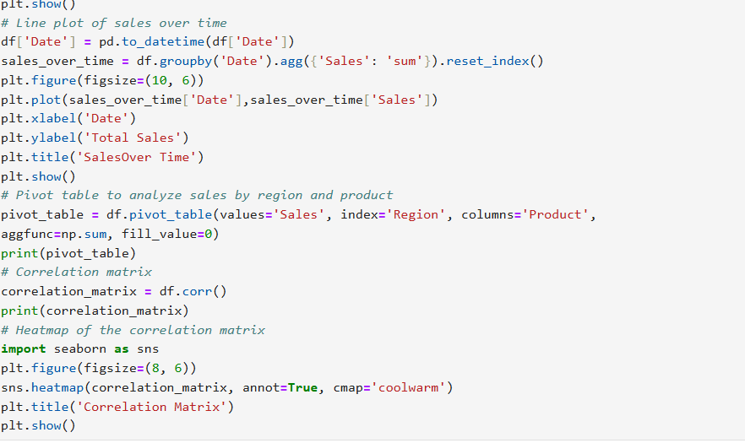
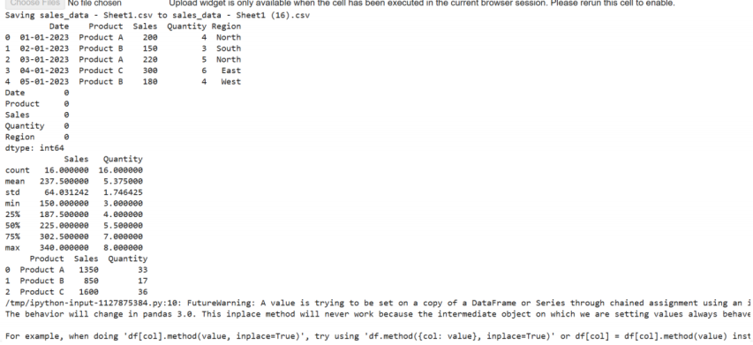
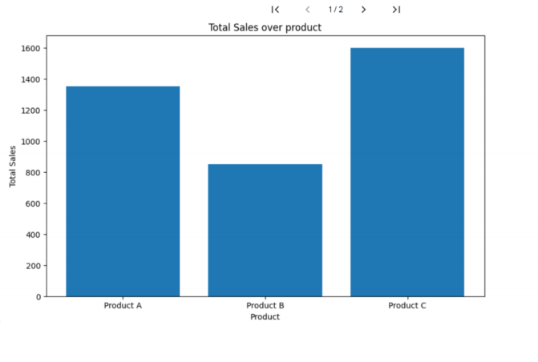
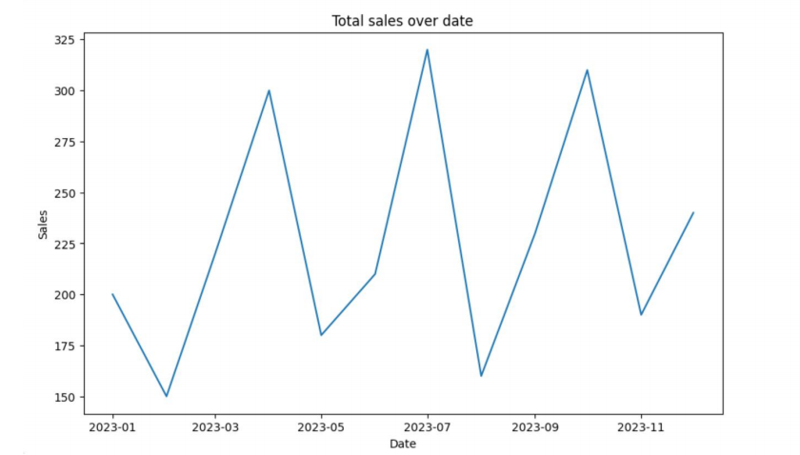
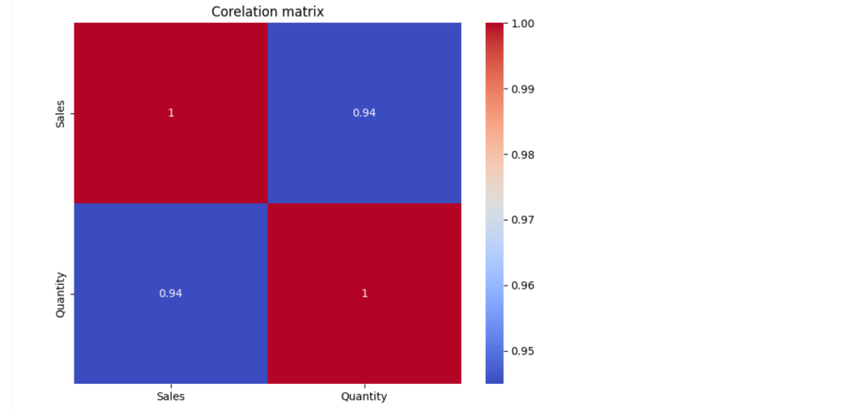
RESULT
Thus the python program to analyze the given dataset and perform data processing is
executed and verified

